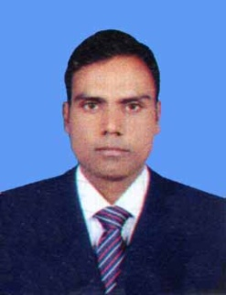***Resume of***

**Md. Aburayhan mia**

Call No: 01722480049

miarayhan558@gmail.com

**CAREER OBJECT:**

To obtain a responsible and challenging position in an organization that will take advantage of my knowledge, education and offer the opportunity for advancement.

**STRENGTH & CAPABILITIES**

* Strong leadership skills and working capability in-group and individual working condition.
* Energetic, Smart, Strong can do attitude, Customer driven, initiative and team oriented.
* Goal oriented hard working ability analytical ability, proactive approach and attain set targets.
* Highly Self-motivated self-confident well connected and adopt a challenging job in any situation.

**EDUCATION QUALIFICATION:**

**M.Sc. (Hon’s) Masters of Science:**

Institution : Rajshahi College,Rajshahi.

Board : National University of Bangladesh.

Subject : Botany (Micro Biology).

Result : Second class

Passing year : 2012

**B.Sc(Hon’s) Bachelor of Science:**

Institution : Joypurhat Govt. College, Joypurhat.

Board : National University of Bangladesh.

Subject : Botany

Result : Second class

Passing year : 2011

**H.S.C Higher Secondary certificate**

Institution : Birampur College.

Board : Rajshahi.

Group : Science

Result : 2.70

Passing year :2006

**S.S.C (Secondary School certificate**

Institution : Binodnogor high school

Board :Rajshahi.

Group :Science

Result :3.38

Passing year :2004

**LANGUAGE PROFICIENCY:**

Good Command on writing, reading and speaking, both in English and Bengali.

**COMPUTER SKILLS:**

MS Office/ database program & Internet (6 month)

**EXPERIENCE:**

Name of company : Renata Limited.

Job Location : Rajshahi

Designation : Senior Professional service officer (Sr.PSO)

Duration :From 16-07-2014 to 31-01-2019

**PERSONAL DETAILS:**

Name : Md. Aburayhan mia

Father’s name : Md. Fozle Rahman

Mother’s Name : Ms. Hansen Khatun

Permanent address : Vill: Boro Magura, Post: be/Kanch daho-5280 PS: Nawabgnj, Dist: Dinajpur.

Present address : Do

Date of Birth : 19 December 1989.

Marital Status : Married.

Religion : Islam.

Sex : male.

Nationality : Bangladeshi

Contact No : 01722-480049

Signature

Md. Aburayhan mia

Date: